Red Hat JBoss Data Virtualization



and Hortonworks



Proof of Technology

Table of Contents
Proof of Technology Overview 3
Use Case One – Sentiment Analysis and Sales Analysis with Hadoop and MySQL 4
Introduction 4
Install Hortonworks Data Platform with Sentiment Data 5
Install MySQL with Sales Data 6
Install SQuirreL Client to test the database connections 6
Install Data Virtualization with Virtual Database 8
Test the unified view 9
Pull the data into Libreoffice spreadsheet 11
Resources 12

Proof of Technology Overview

We will concentrate on three use cases for the Proof of Technology with Hortonworks and Red Hat Jboss Data Virtualization. Each section will go through setting up the environment for the use case and then testing it. Also in the references we have the video links, source code links and supporting collateral links.
Use Case One – Sentiment Analysis and Sales Analysis with Hadoop and MySQL
Use Case Two – Federated Hadoop with Security
Use Case Three– Hadoop Datalake

Use Case One – Sentiment Analysis and Sales Analysis with Hadoop and MySQL

Introduction

This use case is the sentiment analysis and sales analysis with Hadoop and MySQL. It uses one Hortonworks Data Platform VM for the twitter sentiment data and one MySQL database for the sales data. This guide shows how to reproduce the setup and then run the demonstration. The presentation listed in the references section describes the 3 use cases at a high level.
Objective: Determine if sentiment data from the first week of the Iron Man 3 movie is a predictor of sales
Problem: Cannot utilize social data and sentiment analysis with sales management system
Solution: Leverage Jboss Data Virtualization to mashup Sentiment analysis data with ticket and merchandise sales data on MySQL into a single view of the data
We tested on the following two environments:
Environment 1
System 1 Macbook Pro
SquirreL Client, Data Virtualization, VMWare Fusion installed on Mac
HDP Sandbox 2.1 VM
Microsoft Windows VM with Libreoffice and ODBC driver
Environment 2
System 1 Fedora 19
Virtualbox 4.3 with HDP 2
Data Virtualization 6 and JDK 1.7 update 51
MySQL 5.5
System 2 Windows 7
Microsoft Excel 2013 with Powerview
Data Virtualization ODBC Driver

Install Hortonworks Data Platform with Sentiment Data

There are two options to install the HDP with sentiment data. The first is to import the Virtual Box VM with the tweetsbi data already loaded. The second is to use one of the options for the HDP and then load the twitter data in from tweetsbi.csv or the tutorial. For these instructions we are going to concentrate on downloading the HDP Sandbox and importing the tweetsbi data so that you have the most current Sandbox. The sandbox will contain the tweets with sentiment data.
Step 1: Download and install HDP according to the instructions
http://hortonworks.com/products/hortonworks-sandbox/#install
Step 2: Load the sentiment data into the HDP. You can either follow the tutorial below to go through the complete process to create tweetsbi or just load the tweetsbi table from the tweetsbi.csv.
Tutorial: http://hortonworks.com/hadoop-tutorial/how-to-refine-and-visualize-sentiment-data/
To load the data from tweetsbi.csv download the csv.
tweetsbi.csv: https://drive.google.com/file/d/0B5kKwcd4kOq9a3c5R2ZlRXZOdlU/edit?usp=sharing
Next create the tweetsbi table from a file. Make sure the HDP Sandbox is running. Browsing to
http://hdp-vm:8000/hcatalog/create/create_from_file
where hdp-vm is the IP of the sandbox or add hdp-vm to the host file with the IP. Next enter tweetsbi as the tablename, choosing the tweetsbi.csv and then clicking create table. Make sure the delimeter is changed to a comma but keep the other defaults.
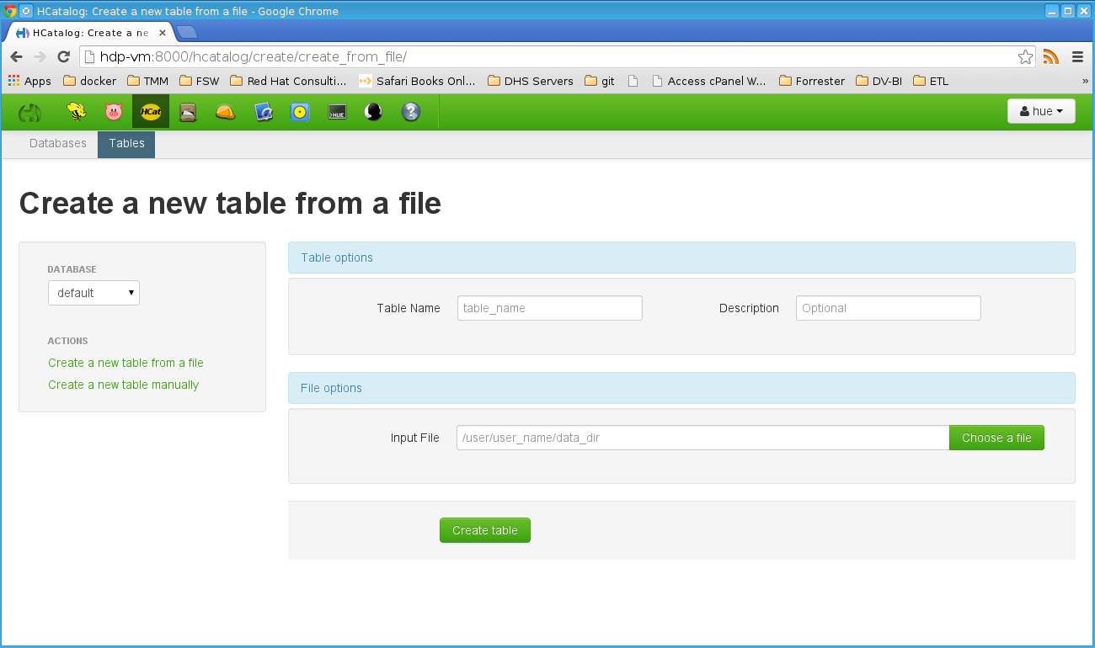
Step 3: In Ambari using admin/admin verify some configuration by Ambari > Services > Configs > Advanced. This should be done to avoid having to issue grants when doing imports.
* hive.security.authorization.enabled, change from true to false
* hive.server2.enable.doAs, change from true to false
Optionally, and recommended for performance, change this option:
* hive.execution.engine, change from mr to tez
Restart All Hive Services
NOTE: Should you skip step 3 or have permission errors when access the tweetsbi table through hive then issue the query below through http://hdp-vm:8000/beeswax/
grant select on table tweetsbi to user hdfs;
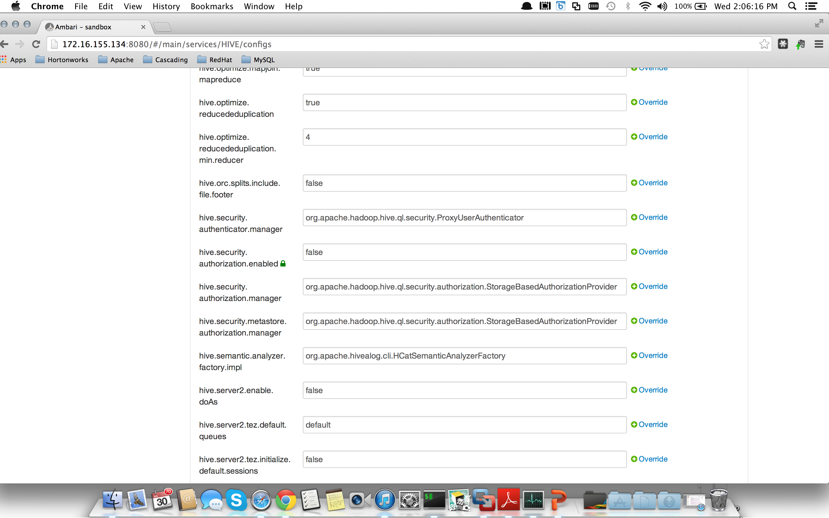

Install MySQL with Sales Data

MySQL will contain the sales data for the iron man movie. MySQL can be installed locally but we will use MySQL on the HDP Sandbox.
Step 1: Grant privileges for the local machine for DV and SquirreL client to connect to the MySQL instance on the sandbox. Log into sandbox as root, type in “mysql” and then enter the following command. You can use % meaning all remote access or you can use the host/local OS IP.
mysql> use mysql
mysql> GRANT ALL ON *.* to admin@'%' IDENTIFIED BY 'admin';
mysql> FLUSH PRIVILEGES;
Step 2: Download the sql script and then scp <sqlscript> root@<sandbox_ip>
https://drive.google.com/file/d/0B5kKwcd4kOq9UWJvSDU5Q1NOcjg/edit?usp=sharing
Step 3: Run the sql script to create the database, table and data
mysql < sales-create-table-and-data.sql
Step 4: Test user and check table by signing on
mysql -u admin -p'admin' hadoopworld
Step 5: Run the SQL command
SELECT * FROM sales;

Install SQuirreL Client to test the database connections

NOTE: SquirreL Client is running on the local/host to connect to DV and the HDP VM.
Step 1: Download and install SquirreL client to test the databases
http://squirrel-sql.sourceforge.net/
Step 2: Install the jdbc drivers by downloading them from the below and placing them in the SquirreL client lib folder
Hive (hive0jdbc-0.11.0.jar): https://drive.google.com/file/d/0B5kKwcd4kOq9MElfam9yaGw2Z1E/edit?usp=sharing
MySQL (mysql-connector-java-5.1.25-bin.jar): https://drive.google.com/file/d/0B5kKwcd4kOq9UC1keS1Id3Fsamc/edit?usp=sharing
Teiid (teiid-8.4.1-redhat-2-jdbc.jar): https://drive.google.com/file/d/0B5kKwcd4kOq9U1pQQjVLMlVUSEk/edit?usp=sharing
Setup the Drivers for according to the below which should give a blue checkmark beside the driver
Hive:
Class Name: org.apache.hive.jdbc.HiveDriver
Example URL: jdbc:hive2://localhost:10000/default
Mysql:
Class Name: com.mysql.jdbc.Driver
Example URL: jdbc:mysql://hostname:3306/dbname
Unififed View (Teiid):
Class Name: org.teiid.jdbc.TeiidDriver
Example URL: jdbc:teiid:theVDB@mm://localhost:31000
Step 3: Setup the database connections according to the below
Hive:
Name: Hive-HDP
Driver: Apache Hive
URL: jdbc:hive2://<sandbox-IP>:10000/default
Username: hdfs
Password: empty
Mysql:
Name: MySQL
Driver: MySQL
URL: jdbc:mysql://<sandbox-IP>:3306/hadoopworld
User: admin
Password: admin
Unififed View (Teiid):
Name: SalesSentimentCountry
Driver: Teiid JDBC Driver
URL: jdbc:teiid:HiveTestVDB@mm://localhost:31000
User: user
Password: user
Step 4: Connect to the databases and select the tables then the content tab to see the database data
A. HDP-VM preview tweetsbi which will take some time for the data to be returned on the first query
B. MYSQL on HDP-VM preview sales which should be quick
C. Sentiment preview which will preview the unified view (NOTE: will not work until after DV has been installed and running)

Install Data Virtualization with Virtual Database

Step 1: Clone the Simplified Data Virtualization template.
https://github.com/kpeeples/simplified-dv-template.git
Step 2: Download Data Virtualization to the distros folder from
http://www.jboss.org/products/datavirt/download/
Step 3: Run the install-run.sh script to install the DV server
Step 4: Stop the server
Step 5: Create the Hive Module by creating the org/apache/hadoop/hive directory under the DV_ROOT/modules/system/layers/base folder and then unzipping the org-apache-hive.zip files to the new folder
https://drive.google.com/file/d/0B5kKwcd4kOq9RkdjdXRKZmxlTUk/edit?usp=sharing
Step 6: Deploy the MySQL JDBC driver from the support folder by going to localhost:8080 and clilcking on the admin console with the username admin and password redhat1!. Then click on manage deployments and click add
Step 7: Setup a new datasource called MySQLSalesModel with the MySQL driver according to
<datasource jndi-name="java:/MysqlDatasource" pool-name="MysqlDatasource" enabled="true">
<connection-url>jdbc:mysql://<sandbox_IP>:3306/hadoopworld</connection-url>
<driver>mysql-connector-java-5.1.25-bin.jar</driver>
<security>
<user-name>admin</user-name>
<password>admin</password>
</security>
</datasource>

Step 8: Setup a new datasource called HiveConnection with the Hive driver according to
<datasource jndi-name="java:/HiveConnection" pool-name="HiveConnection" enabled="true">
<connection-url>jdbc:hive2://<sandbox_IP>:10000/default</connection-url>
<driver>hive</driver>
<security>
<user-name>hdfs</user-name>
<password>admin</password>
</security>
</datasource>

Step 9: Deploy the HiveTestVDB by following the same process as step 6
https://drive.google.com/file/d/0B5kKwcd4kOq9Z2FJYXF5VFlrdnM/edit?usp=sharing
Step 10: Start the server by running standalone.sh -b 0.0.0.0 from the DV_ROOT/bin

Test the unified view

Data Virtualization Dashboard
Step 1: Test the Data Virtualization Dashboard. While the DV server is running browse to localhost:8080/dashboard
Step 2: Create the Teiid external connections
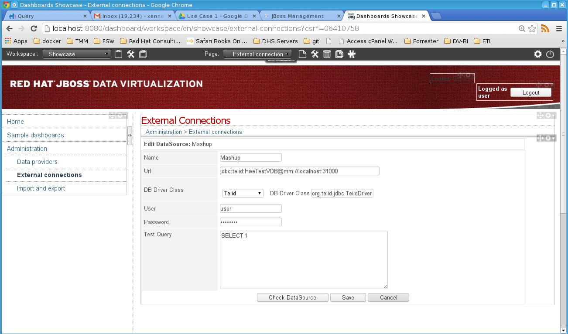
Step 3: Create the data provider
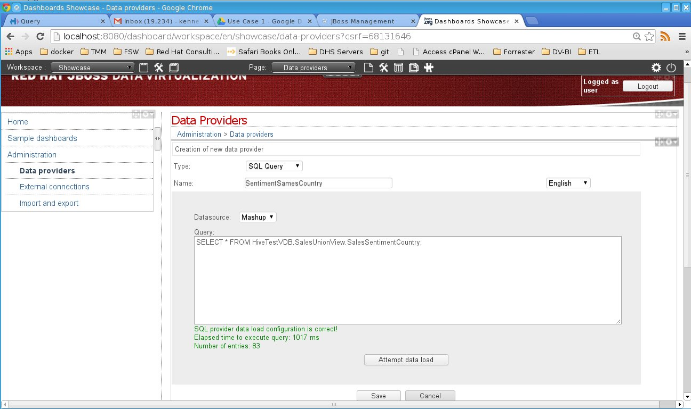

Step 4: Create the workspace
Step 5: Create a new page after selecting the newly created workspace
Step 6: Create a new panel after selecting the newly created page
Step 7: Select the key performance indicator and drag and drop to the panel
Step 8: Select the created data provider
Step 9: Select the Data Table to see the data in a spreadsheet
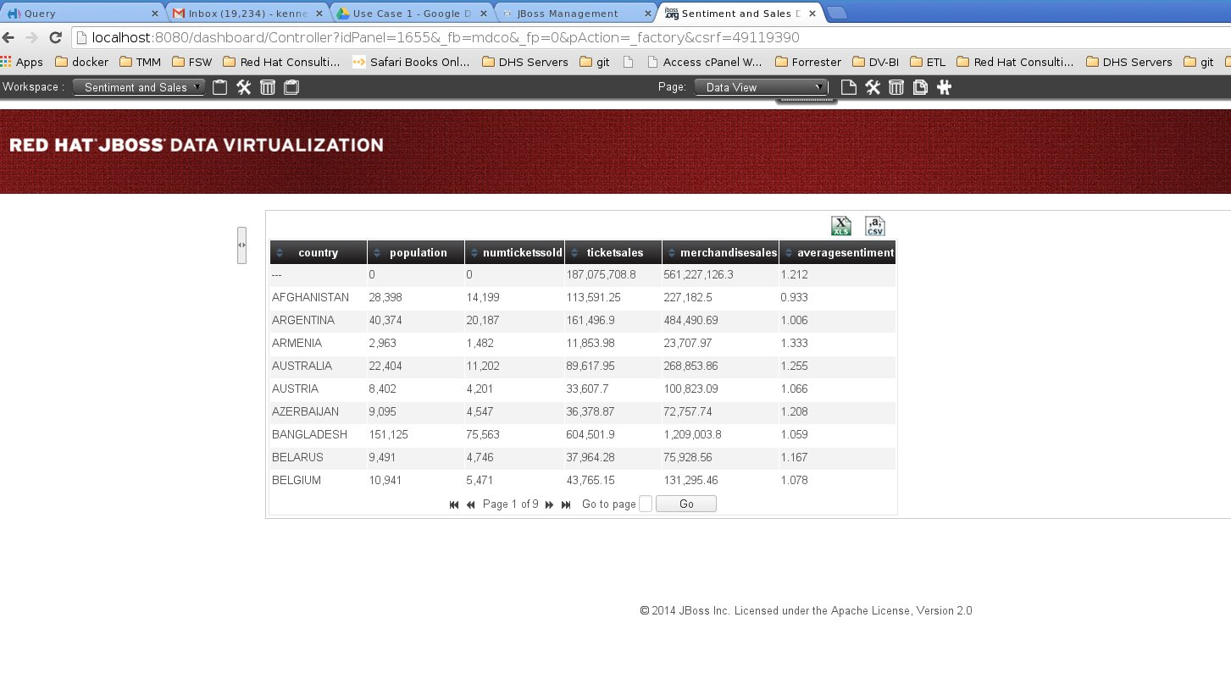

SquirreL Client
Step 1 Preview the content for the SalesSentimentCountry Table with the datasource that was setup above
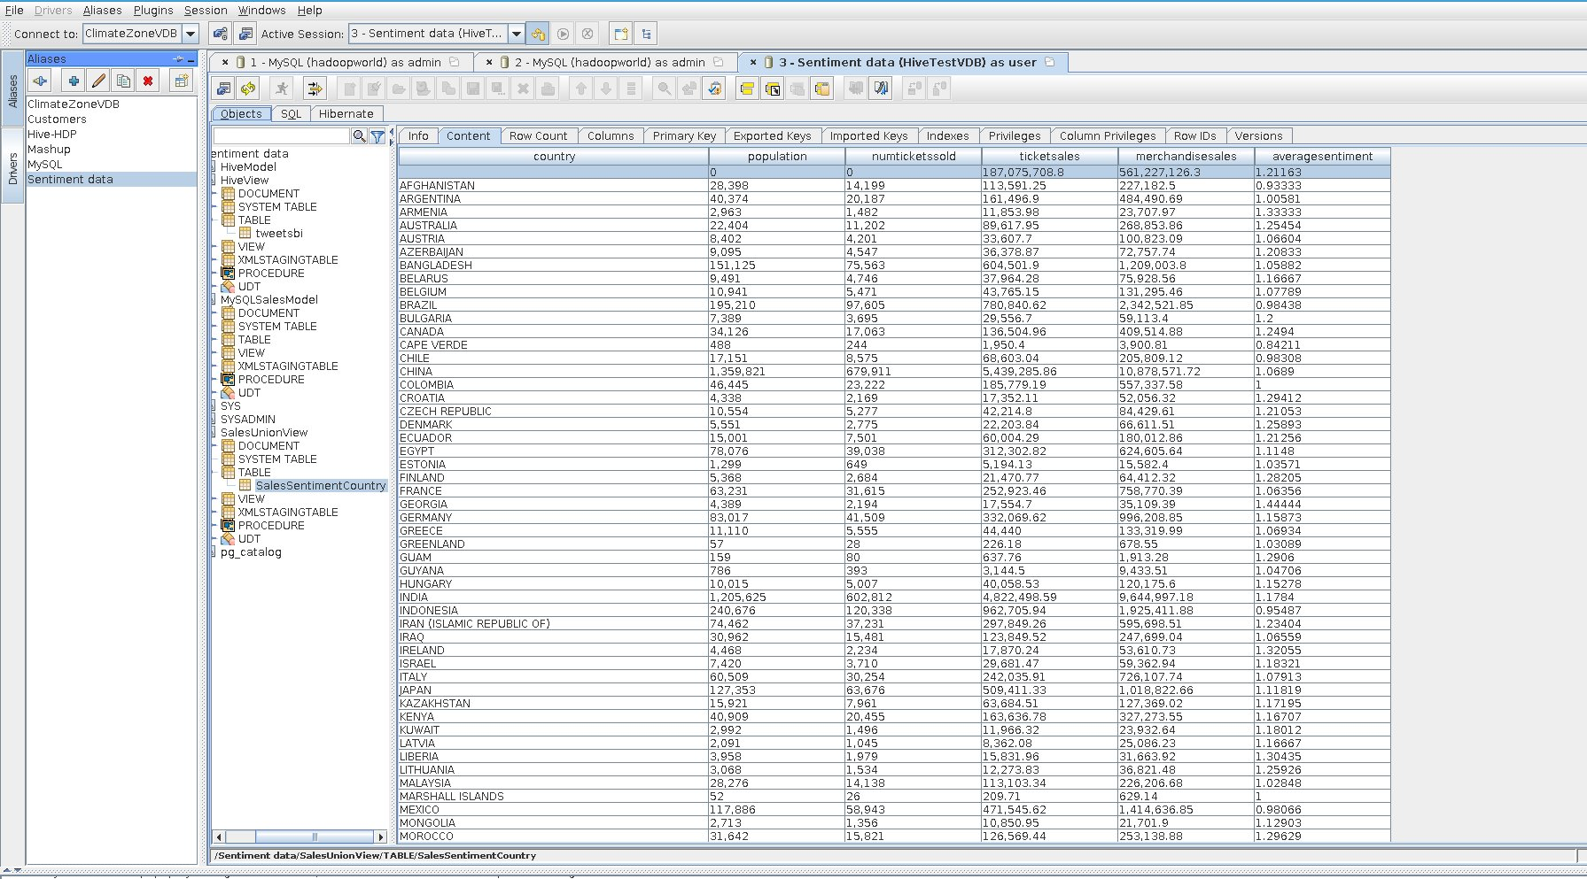

Pull the data into Libreoffice spreadsheet

Step 1: Install the ODBC Driver According to the platform
Step 2: Create a new database connection in Libreoffice Calc

Resources
High Level Presentation - https://speakerdeck.com/kpeeples/hortonworks-and-red-hat-proof-of-technology
Hortonworks Sandbox - http://hortonworks.com/products/hortonworks-sandbox/#install
Videos:
http://vimeo.com/user16928011/hortonworksusecase1short
http://vimeo.com/user16928011/hortonworksusecase1long

Source :: Github (Data Virtualization)
https://github.com/DataVirtualizationByExample/HortonworksUseCase1

